*************React js************

REACT is library / framework : react is JavaScript library

Syntax of using inline css in reactjs :

<div style={{backgroundColor:"#f368e0" ,padding:"20px"}} >

Installation :

1. Install node .js
2. Install react developer tool chrome extension
3. Install vs code extension Thunder client ( it is alternative of postman )
4. Install vs code extension ES7 React/Redux/GraphQL
5. Install vs code extension bracket pair colorizer
6. Install vs code extension Auto rename Tag
7. Install vs code extension live server

🡺 Installing create react app :

We can install create-react-app by two ways :

1. in terminal : npm I create-react-app -g (it will going to install in my system globally and consume our space , we have a better way of installing it by second method )

2. in terminal : npx create-react-app my-app (it will not going to install in our system it is like we are taking udhar from the react)

App.js :

import logo from './logo.svg';

import './App.css';

*function* App() {

  return (

    <div className="App">

      <header className="App-header">

        <img src={logo} className="App-logo" alt="logo" />

        <p>

          Edit <code>src/App.js</code> and save to reload.

        </p>

        <a

          className="App-link"

          href="https://reactjs.org"

          target="_blank"

          rel="noopener noreferrer"

        >

          Learn React

        </a>

      </header>

    </div>

  );

}

export default App;

note : all the red linear are jss:

ii) if I want to add any thing to that then it have to use jss fragments : <> at the end </>

iii) To add java script we need to use {};

iv) when we are using component then we have to use closing tag . which is must otherwise it will going to give error.

* Want to emit to work in vscode :

Step 1 : open setting

Step 2: search emit

Setp 3 : add : key:javascript , value :javascriptreact

🡺 What is react ?

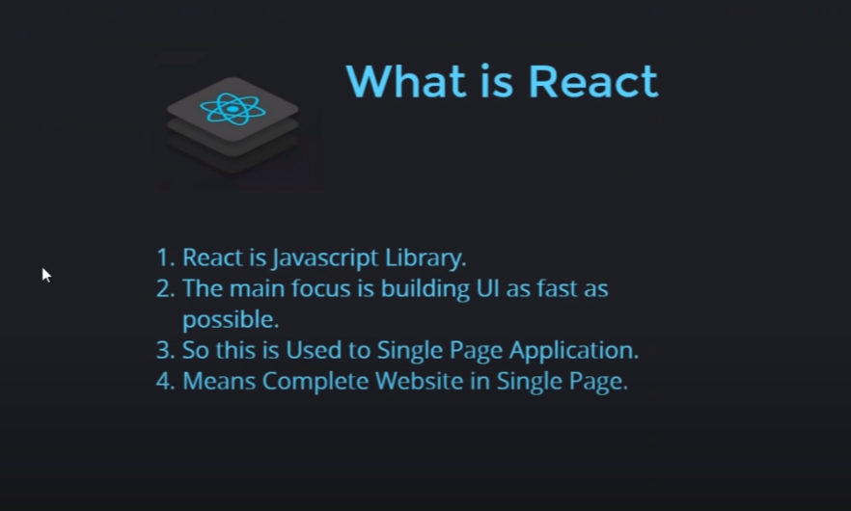

🡺 Why react ,why not Angular or vue ?

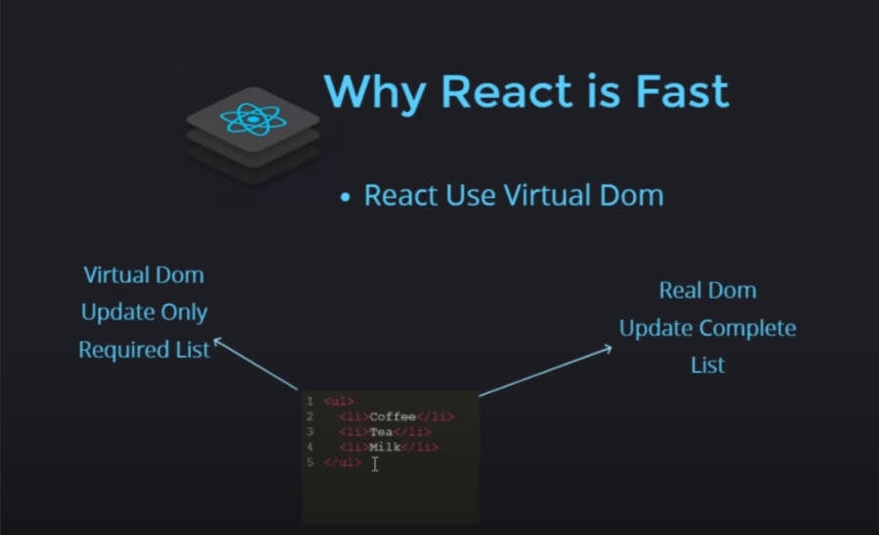

🡺 History :

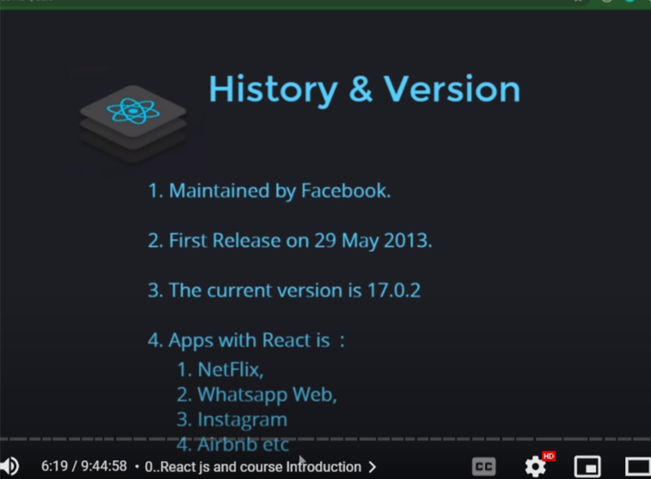

🡺 Alternative of npm(node package manager ) :

That is : yan

🡺 pakage.jason

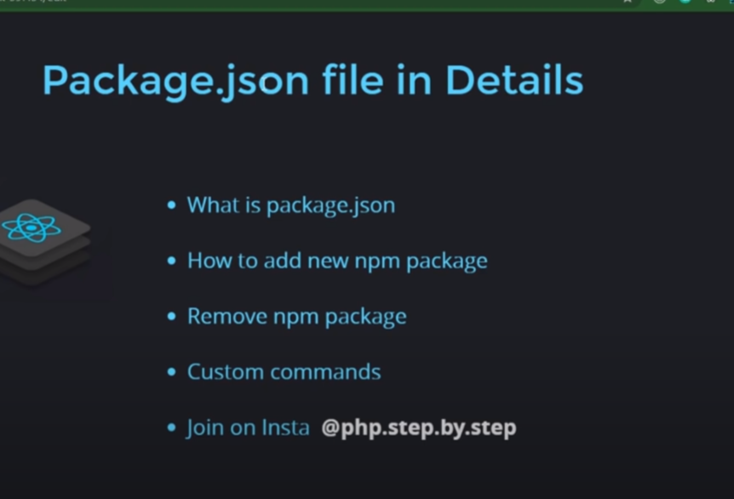

* Most important file . (it contains all the information of the module we have install and if node-module get delete then we can still can recover it from pakage.jason by running command ) .
* How to add new npm package : run command : npm i package_name
* Remove npm pakage :run command : npm uninstall package_name
* Custom commands : npm run command_name (ex:colors,express,or any other name that I have changed)

Component :

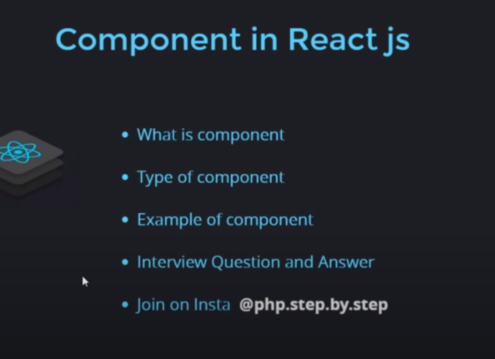

1. what is component ?



2.Type of component ?

Major two type: i) functional and class component

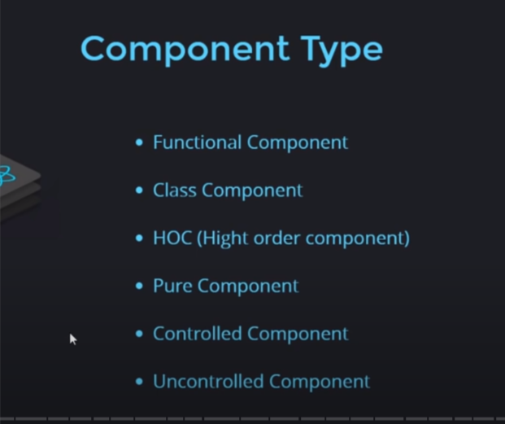

1. Functional component :

Step1 : Make a file java Script file with first letter capital under which write the code .

*function* User()

{

    return(

        <h1>user component</h1>

    )

}

export default User;

step 2 : use It by importing it :

import User from "./User";

<*User*/>

🡺 different way of adding / importing component :

1.

Step 1 :

*function* User()

{

    return(

        <h1>user component</h1>

    )

}

export default User;

step 2 :

import User from "./User";

<*User*/>

2. by not using export default filename :

Step 1 :

export *function* User()

{

    return(

        <h1>user component</h1>

    )

}

Step 2 :

import {User} from "./User";

and

<*User*/>

3.writing component in same file in which we want it to be use :

*function* User() {

  return (

    <div className="User">

      <h1>we are in user now</h1>

      <calling />

    </div>

  );

}

*function* calling() {

  return <h1>Fucnction is Calling</h1>;

}

Class Component:

import React,{Component} from 'react';

export  *class* User extends Component{

    render()

    {

        return(

        <h1>Hell to Class Component</h1>

        )

    }

}

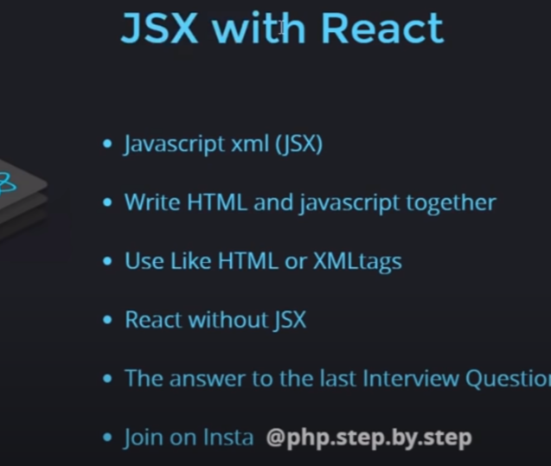

Can we write our code without JSX ?

Yes . But it will be complex like :

import React from 'react';

export default  *function* User(){

    return React.createElement('h1',null,"Hello world!",) // crerating a heading

click event and use of variable :

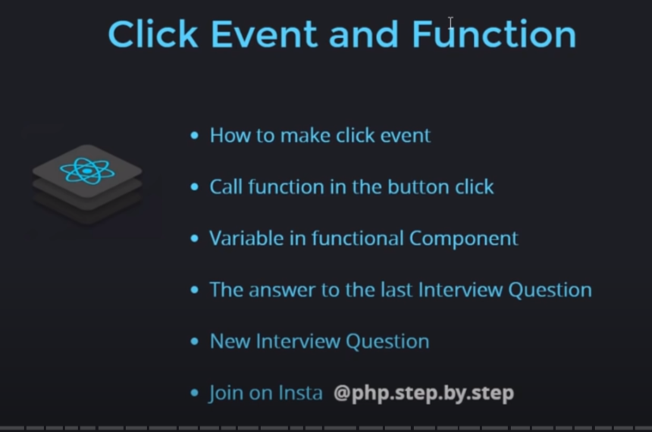

1. For making click event we use arrow function or call click function by {} .

a. Click event by function :

import './App.css';

*function* App() {

  return (

    <div className='App'>

      <h1>Hello Ajaj</h1>

      <button onClick={()*=>*{

        alert("You clicked me");

      }}>Click me</button>

    </div>

  );

}

export default App;

B: click event by function call

import './App.css';

*function* App() {

*function* hello(){

    alert("You have clicked me");

  }

  return (

    <div className='App'>

      <h1>Hello Ajaj</h1>

      <button onClick={hello}>Click me</button>

    </div>

  );

}

export default App;

State in Functional component:

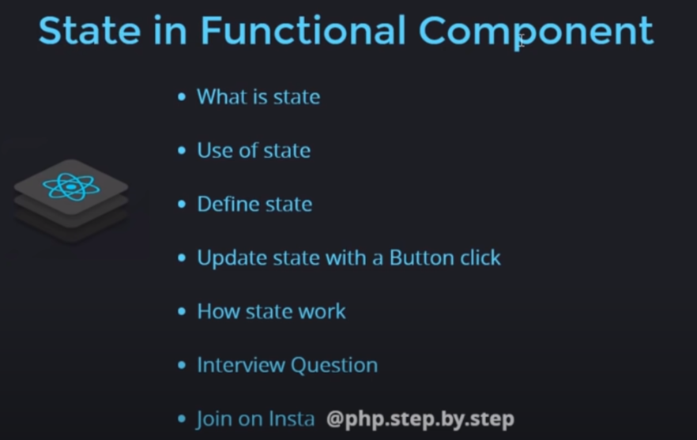

1. What is state?

State is like an object. Where we can store our data.

If we have to use variable the we will use state .

2. why state why not variable ?

When ever we update our date state re render itself but variable do re render itself .

2. defining state :

import './App.css';

import {useState} from 'react';

*function* App() {

*let* [data,setdata]=useState("Anupam");

*function* hello(){

     setdata("Ajaj");

  }

  return (

    <div className='App'>

      <h1>{data}</h1>

      <button onClick={hello}>Click me</button>

    </div>

  );

}

export default App;

state in class component :

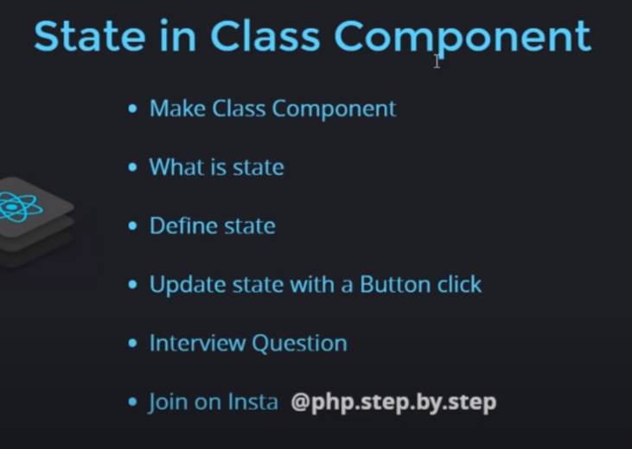

Defining state in class :

import './App.css';

import React ,{Component} from 'react';

*class* App extends Component {

*constructor*(){

    super();

    this.state={

      data:"Anpuam",

      setdata:"Ajaj"

    }

  }

  render()

  {

    return(

      <div className='App'>

        <h1>{this.state.data}</h1>

        <button onClick={()*=>*{

          this.setState({data:"Ajaj"});

        }}>Click Me</button>

    </div>

    )

  }

}

export default App;

Props : props is used to pass parameter in function .

1. Props with the function component :

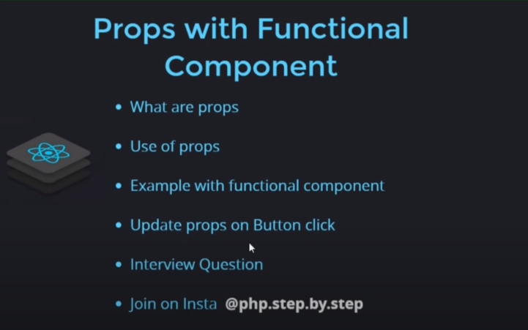

Syntax and uses:

App.js file:

import { Component } from 'react';

import './App.css';

import Student from './Student';

*function* App(){

  return(

    <div className='App'>

      <*Student* name={"Ajaj Alam"} email={"2020umt1399@mnit.ac.in"} Adress={{home:"BEttiah",moboile:111}}/>

      <*Student* name={"Anupam"} email={"2020umt1384@mnit.ac.in"} Adress={{home:"BEttiah",moboile:111}}/>

      <*Student* name={"Ajaj Alam"} email={"2020umt1399"} Adress={{home:"BEttiah",moboile:111}}/>

    </div>

  )

}

export default App;

Student.js file:

export default *function* Student(*props*) {

    return (

        <div style={{backgroundColor:"#f368e0" ,marginBottom:"25px"}} >

            <h3>{*props*.name}</h3>

            <h4>Email: {*props*.email}</h4>

            <h5>Adress:{*props*.Adress.home} , moboile:{*props*.Adress.moboile}</h5>

        </div>

    )

}

** Changing the name of props:

App.js file :

import { Component } from 'react';

import './App.css';

import Student from './Student';

import { useState } from 'react';

*function* App() {

*const* [name, setname] = useState("Ajaj");

  return (

    <div className='App'>

      <*Student* name={name} />

      <button onClick={() *=>* {

        setname("Anupam");

      }}>Click me</button>

    </div>

  )

}

Student.js file

import { useState } from "react"

export default *function* Student(*props*) {

    return (

        <div style={{ backgroundColor: "#f368e0", marginBottom: "25px" }} >

            <h2>{*props*.name}</h2>

        </div>

    )

}

2. Props with the class component :

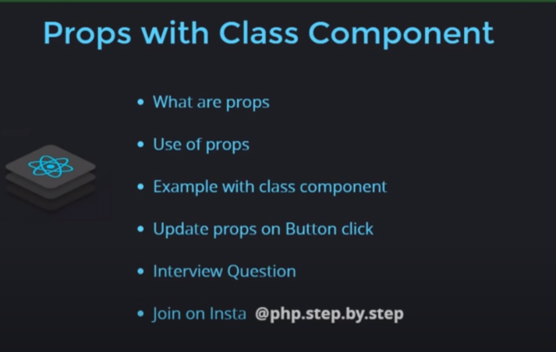

Syntax :

App.js

import React,{ Component } from 'react';

import './App.css';

import Student from './Student';

*class* App extends Component {

  render()

  {

    return (

      <div className='App'>

        <*Student* name="Ajaj Alam" E_mail="2020umt1399@mnit.ac.in" Adress={{Home:"Bettiah", mobile_no:111}}/>

        <*Student* name="Ajaj Alam" E_mail="2020umt1399@mnit.ac.in" Adress={{Home:"Bettiah", mobile_no:111}}/>

        <*Student* name="Ajaj Alam" E_mail="2020umt1399@mnit.ac.in" Adress={{Home:"Bettiah", mobile_no:111}}/>

      </div>

    )

  }

}

export default App;

Student.js

import { Component } from "react";

export default *class* Student extends Component {

    render() {

        return (

            <div style={{ backgroundColor: "#0abde3", marginBottom: "20px" }}>

                <h2>Hello {this.props.name}</h2>

                <h3>Email:{this.props.E_mail}</h3>

                <p>Adress:{this.props.Adress.Home} , Mobile:{this.props.Adress.mobile_no}</p>

            </div>

        )

    }

}

Changing the name on the button click :

App.js

import React, { Component } from 'react';

import './App.css';

import Student from './Student';

*class* App extends Component {

*constructor*() {

    super();

    this.state = {

      name: "Ajaj"

    }

  }

  render() {

    return (

      <div className='App'>

        <*Student* name={this.state.name} />

        <button onClick={()*=>*{

          this.setState({name:"Anupam"})

        }}>click me</button>

      </div>

    )

  }

}

export default App;

Student.js

import { Component } from "react";

export default *class* Student extends Component {

    render() {

        return (

            <div style={{ backgroundColor: "#0abde3", marginBottom: "20px" }}>

                <h2>Hello {this.props.name}</h2>

            </div>

        )

    }

}

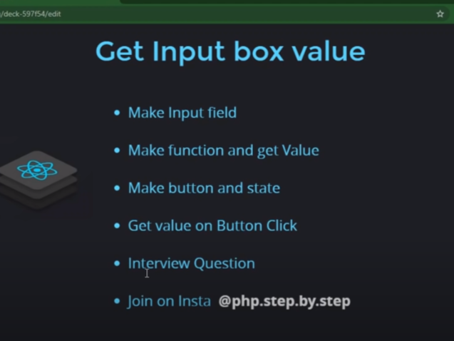

1.Make input field and make function and get value?

import React, {useState } from "react";

import "./App.css";

*function* App() {

*const* [data, getda] = useState(null);

*function* getdata(*val*) {

    // console.log(val.target.value);

    getda(*val*.target.value);

  }

  return (

    <div className="App">

      <h1>{data}</h1>

      <input type="text" onChange={getdata} />

    </div>

  );

}

export default App;

2.Make a button and state and get value on button click?

import React, {useState } from "react";

import "./App.css";

*function* App() {

*const* [data, getda] = useState(null);

*const* [btndata,btngetdata]=useState(false)

*function* getdata(*val*) {

    // console.log(val.target.value);

    getda(*val*.target.value);

  }

  return (

    <div className="App">

      {

        btndata?<h1>{data}</h1>:null

      }

      <input type="text" onChange={getdata} />

      <button onClick={()*=>*{

        btngetdata(true);

      }}>Click Me</button>

    </div>

  );

}

export default App;

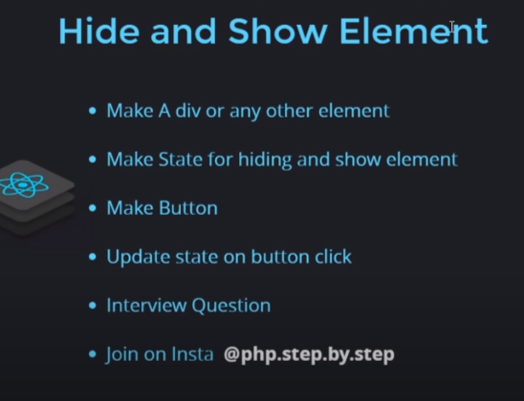

1.Make button and update state on button click ?

import React, { useState } from "react";

import "./App.css";

*function* App() {

*const* [data, getdata] = useState(false);

  return (

    <div className="App">

      {data ? <h1>Hello World</h1> : null}

      <button

        onClick={() *=>* {

          getdata(true);

        }}

      >

        Show

      </button>

      <button

        onClick={() *=>* {

          getdata(false);

        }}

      >

        hide

      </button>

    </div>

  );

}

export default App;

1. Making a toggle button?
2. import React, { useState } from "react";
3. import "./App.css";
4. *function* App() {
5. *const* [data, getdata] = useState(false);
6. return (
7. <div className="App">
8. {data ? <h1>Hello World</h1> : null}
9. <button onClick={()*=>*{
10. getdata(!data)
11. }}>toggle</button>
12. </div>
13. );
14. }
15. export default App;

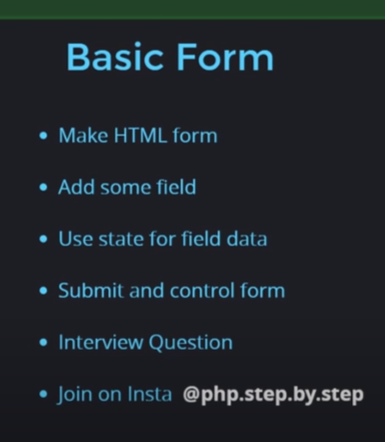

import React, { useState } from "react";

import "./App.css";

*function* App() {

*const* [name, getname] = useState("");

*const* [tnc, gettnc] = useState(false);

*const* [intrest, getintrest] = useState("");

  return (

    <div className="App">

      <h1>Form handeling</h1>

      <form

        onSubmit={(*e*) *=>* {

          console.warn(name, tnc, intrest);

*e*.preventDefault();

        }}

      >

        <input

          type="text"

          placeholder="Enter your input" value={name}

          onChange={(*e*) *=>* {

            getname(*e*.target.value);

          }}

        />

        <br />

        <br />

        <select

          onChange={(*e*) *=>* {

            getintrest(*e*.target.value);

          }}

        >

          <option>Select Option</option>

          <option>Marvel</option>

          <option>Dc</option>

        </select>{" "}

        <br />

        <br />

        <input

          type="checkbox"

          onChange={(*e*) *=>* {

            gettnc(*e*.target.checked);

          }}

        />

        Accept Terms and condition <br />

        <br />

        <input type="submit" value="submit" />

      </form>

    </div>

  );

}

export default App;

use of if, else if, else in the reactJS :

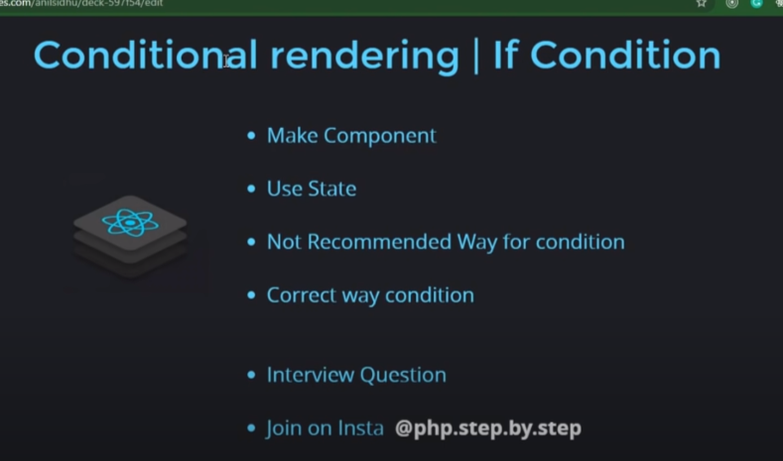

import React, { useState } from "react";

import "./App.css";

*function* App() {

*const* [data, getadata] = useState(2);

  return (

    <div className="App">

      <h1>Condition Rendering</h1>

      {data === 1 ? (

        <p>calling 1</p>

      ) : data === 2 ? (

        <p>calling 2</p>

      ) : (

        <p>calling 3</p>

      )}

    </div>

  );

}

export default App;

* Passing function as props :

App.js file

import "./App.css";

import Student from "./Student";

*function* App() {

*function* info() {

    alert("Name: Ajaj , id:2020UMT1399");

  }

  return (

    <div className="App">

      <*Student* data={info} />

    </div>

  );

}

export default App;

Student.js file

export default *function* Student(*props*) {

  return (

    <div>

      <h1>passing function as props</h1>

      <button onClick={*props*.data}>Click me</button>

    </div>

  );

}

React life cycle :

React life cycle has three phase :

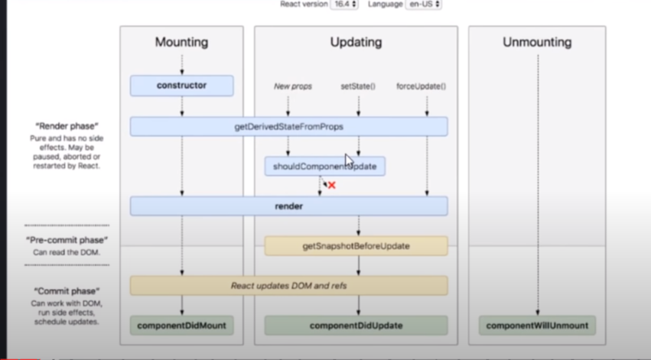

Methods of life cycle :

A) constructor : we use constructor with the class , with function component we will use hooks .First to call when our html and css or js was not mount (ready to excute)



1.what is constructor?

During class component constructor is the first thing which call .

import "./App.css";

import Student from "./Student";

import React from "react";

*class* App extends React.Component {

*constructor*() {

    super();

    {

      this.state = {

        name: "Ajaj",

      };

    }

  }

  render() {

    return (

      <div className="App">

        <h1>Constuctor Tutorial</h1>

      </div>

    );

  }

}

export default App;

interview question : Can we use Props in constructor ?

ans : Yes we can use props in constructor .

2. Render method : (2nd method called in life cycle)

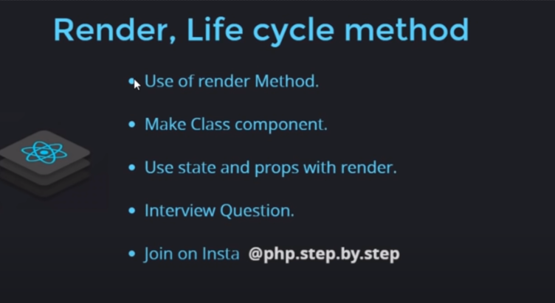

1. use of render method?

In class component we use render method .To re render what ever we write code in it.

2.When will render call ?

i) when the particular class component called

ii)When we update data with the props

iii)When we update data with state

3.interview question : can we update state in render and is it a good thing to do ?

Ans : yes we can update state in render ,but it will be not a good practice because render will call when object is formed,stateupdate and props update , so it will go in the infinte loop .

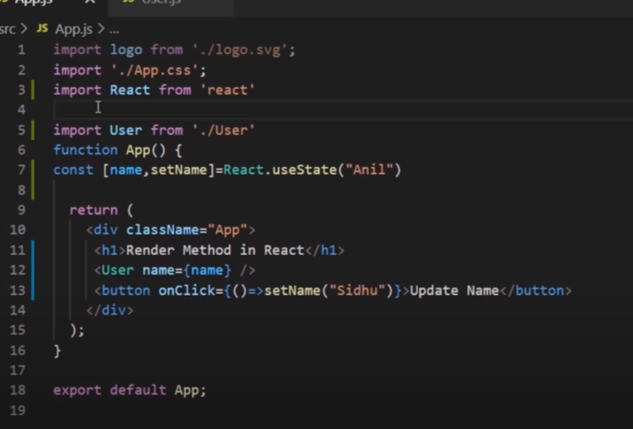

3. componentDidMount: calling order will be : constructor->render->componentDidMount



1. When componentDidMount will be called?

ComponentDidMount will called when our html,css,javascript code are ready to excute then component did mount will called.

2.USES OF COMPONENTDIDMOUNT ?

It use to call the api .

3. Diffrence between componentDidMount and componentdidupdate?

Componentdidmount will called when our html ready to excute and componentdidupdate will be called when we have to update data in it.

4.why do we call api in componentDidMount ?  
because componentDidmount will have no effect of props or state , so it will not going to update again and again .so we do not have to call the api again and again .

import "./App.css";

// import Student from "./Student";

import React from "react";

*class* App extends React.Component {

*constructor*() {

    super();

    console.warn("constructor has called");

  }

  componentDidMount() {

    console.warn("ComponentDidMount has called .");

  }

  render() {

    console.warn("render has called");

    return(

      <div className="App">

        <h1>ComponentDidMount Lecture</h1>

      </div>

    )

  }

}

export default App;

4.ComponentDidUpdate



1.When will componentDidUpdate will run ?

componentDidUpdate will run only when state or props will update , it will not going to run when object is create .

2.can we update our state in componentDidUpdate and how ?

Ans : yes we can update our state in componentDidUpdate . but we have to update it with condition otherwise it will going to go into a infinite loop . because componentDidUpdate will excute only when state udate or props called .

3.parameter inside the componentDidMount ?

componentDidMount(prestate,preprops,sanpsot);

prestate:will give previous state

preprops:will give previous props

4.can we stop componentDidUpdate to call ?

Yes we can by using ,

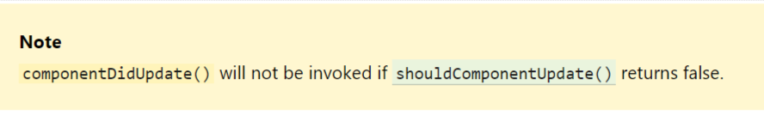

5.ShouldComponentUpdate() method :

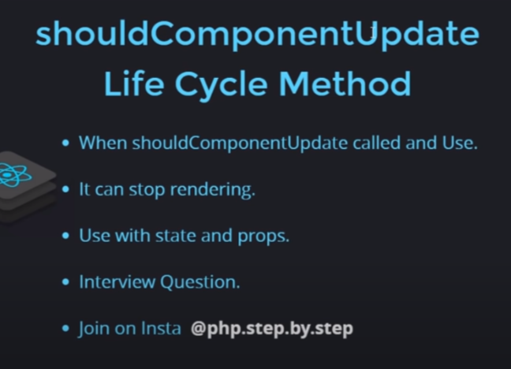

1.Where ShouldComponentUpdate() called and use ?

shouldComponentUpdate is a update

shouldComponentUpdate can be to stop any of the life cycle method to re render .

2.bydefault it return false : means it our state or props will not going to update by default if we call shouldComponentUpdate() , for updating we have to return true with condition or without condition.

import "./App.css";

// import Student from "./Student";

import React from "react";

*class* App extends React.Component {

*constructor*(){

    super();

    this.state={

      count:0

    }

  }

  shouldComponentUpdate(){

    console.log("shouldcomponentUPdate called " ,this.state.count);

    return true;

  }

  render() {

    console.warn("render has called");

    return(

      <div className="App">

        <h1>Should Component Update {this.state.count}</h1>

        <button  onClick={()*=>*{

          this.setState({count:this.state.count+1})

        }}>click me</button>

      </div>

    )

  }

}

export default App;

interview Question : can we call api in componentDidUdate ?

ans : yes we can call api in componentDidUpdate but with condition because compoentDidUpdate will going to re render itself when state update so in that case we have call api again and again .

interview Question : between componentDidUpdate() and ShouldComponentUpdate() which will called first ?

ans : shouldComponentUpdate() will called first than componentDidUpdate();

6.componentWillUnmount():

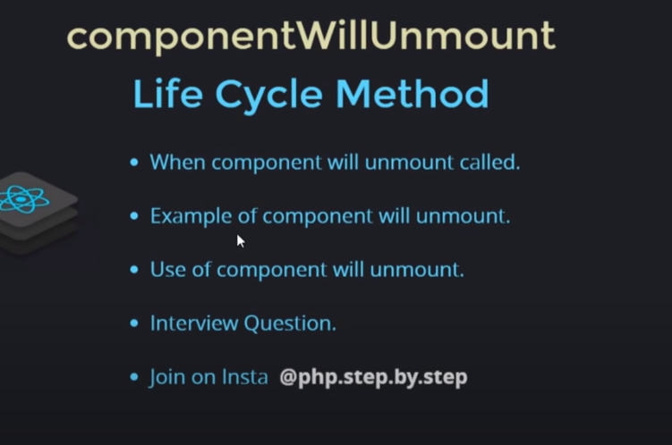

1.When Component will unmount will called?

Whenever we hide or remove the component from the dom then the componentWillUnmount() will called.

Example :

App.js

import "./App.css";

import Student from "./Student";

import React from "react";

*class* App extends React.Component {

*constructor*() {

    super();

    this.state = {

      show: true,

    };

  }

  componentWillUnmount(){

    console.warn("component will unmount called");

  }

  render() {

    return (

      <div className="App">

        <h1>Component Will Unmount</h1>

        {this.state.show ? <*Student*/> : null}

        <button

          onClick={() *=>* {

            this.setState({ show: !this.state.show });

          }}

        >

          toggle

        </button>

      </div>

    );

  }

}

export default App;

Stuedent.js

import React from "react";

export default *class* Student extends React.Component {

  componentWillUnmount(){

    console.warn("component will unmount has called!");

  }

  render() {

    return (

      <div>

        <h1>passing function as props</h1>

      </div>

    );

  }

}

Interview question : componentWillUnmount called after or before the removal of that element?

Ans : componentwillunmount() will called just before the removal of the element .

We can see it by :using alert inside the componentWillUnmount()

import React from "react";

export default *class* Student extends React.Component {

  componentWillUnmount(){

    alert("component has removed!");

  }

  render() {

    return (

      <div>

        <h1>passing function as props</h1>

      </div>

    );

  }

}

🡺 HOOKS :

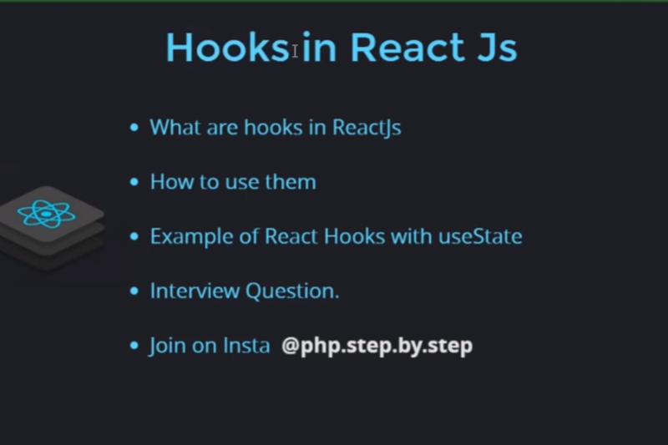

1.What is hooks ?

Hooks is used when we have to use the method of life cycle of functional component .

2.How to use hooks ?

Hooks are start with “use” keywords .

We need to import them from react.

By : import React ,{hooks} from “react”

Interview question: Can we use hooks with the class components ?

Ans : no , we cannot use hooks with the class component .

Hooks method :

1.useEffect

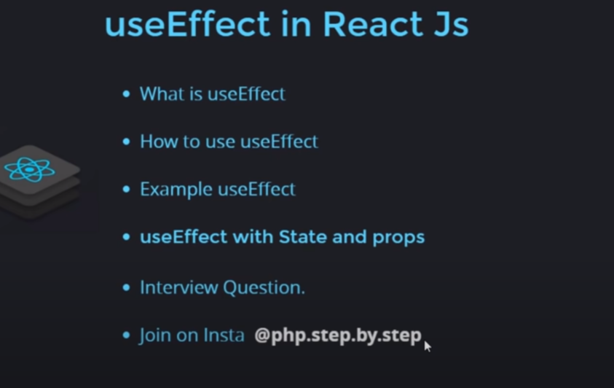

note : useEffect will be going to excute after the excution of main component .

1.What is useEffect?

UseEffect is hooks is used as life cycle for functional component.

2. useEffect will going to run when jxs will mount , when we update state and props .

3.We can define as many useEffect as we want in single function component.

useEffect without condition :

import "./App.css";

// import Student from "./Student";

import React from "react";

*function* App() {

*const* [data, setdata] = React.useState(0);

  React.useEffect(() *=>* {

    console.log("use effect called !");

  });

  return (

    <div className="App">

      <h1>Use Effect Tutorial {data}</h1>

      <button

        onClick={() *=>* {

          setdata(data + 1);

        }}

      >

        click me

      </button>

    </div>

  );

}

export default App;

if we want the use effect not to perform any work :we pass empty bracket [] as a second parameter in useEffect .

import "./App.css";

// import Student from "./Student";

import React from "react";

*function* App() {

*const* [data, setdata] = React.useState(0);

  React.useEffect(() *=>* {

    console.log("use effect called !");

  },[]);

  return (

    <div className="App">

      <h1>Use Effect Tutorial {data}</h1>

      <button

        onClick={() *=>* {

          setdata(data + 1);

        }}

      >

        click me

      </button>

    </div>

  );

}

export default App;

Use effect with state and props :



1.use Effect with specific state?

import "./App.css";

// import Student from "./Student";

import React from "react";

*function* App() {

*const* [data1, setdata1] = React.useState(100);

*const* [data2, setdata2] = React.useState(10);

  React.useEffect(()*=>*{

    console.log("useEffect called for data1");

  },[data1]);

  React.useEffect(()*=>*{

    console.log("useEffect called for data2");

  },[data2]);

  return (

    <div className="App">

      <h1>cout of data 1:{data1}</h1>

      <h1>cout of data 2:{data2}</h1>

      <button

        onClick={() *=>* {

          setdata1(data1 + 1);

        }}

      >

        for Data1

      </button>

      <button

        onClick={() *=>* {

          setdata2(data2 + 1);

        }}

      >

        for Data2

      </button>

    </div>

  );

}

export default App;

2.Use Effect with the specific props

App.js

import "./App.css";

import Student from "./Student";

import React from "react";

*function* App() {

*const* [data1, setdata1] = React.useState(100);

*const* [data2, setdata2] = React.useState(10);

  return (

    <div className="App">

      <h1>Use Effect with Specfic props</h1>

      <*Student* data1={data1} data2={data2}/>

      <button

        onClick={() *=>* {

          setdata1(data1 + 1);

        }}

      >

        for Data1

      </button>

      <button

        onClick={() *=>* {

          setdata2(data2 + 1);

        }}

      >

        for Data2

      </button>

    </div>

  );

}

export default App;

Student.js

import React from "react";

export default *function* Student(*props*) {

  React.useEffect(()*=>*{

    console.log("use Effect of data 1 has called")

  },[*props*.data1])

  React.useEffect(()*=>*{

    console.log("use Effect of data 1 has called")

  },[*props*.data2])

  return (

    <div>

      <h1>cout of data 1:{*props*.data1}</h1>

      <h1>cout of data 2:{*props*.data2}</h1>

    </div>

  );

}

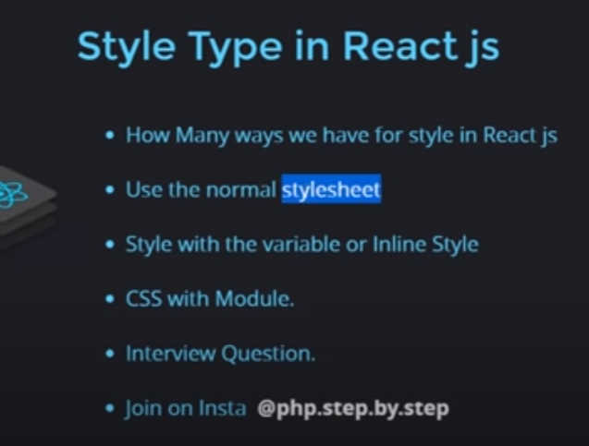

1.Type of Css ?

We have three type of css : i)inline CSS ii)External CSS iii) .module.css

i)inlineCSS

import "./App.css";

import Student from "./Student";

import React from "react";

import './web.css';

import style from "./web.module.css";

*function* App() {

*const* [data1, setdata1] = React.useState(100);

*const* [data2, setdata2] = React.useState(10);

  return (

    <div className="App">

      <h1 style={{backgroundColor:"#fd79a8" , color:"black" , marginBottom:"10px"}}>INLINE CSS</h1>

      <h1 className="externalcss">EXTERNAL CSS</h1>

      <h1 className={style.modulecss} >MODULE CSS</h1>

    </div>

  );

}

export default App;

React bootstrap :



1.What is boot strap ?

Ans : bootstrap is frontend framework . it is used to make responsive website .

2. Install Bootstrap?

Ans : to install bootstrap we need to go to website react bootstrap from their we get information how to download it.

<https://react-bootstrap.github.io/getting-started/introduction>

Note : Must Read documentation.



1.Make List from array ?

import "./App.css";

import {Table} from 'react-bootstrap';

*function* App(){

*let* User=[

    {name:"Ajaj Alam" , id:"2020UMT1399" , contact:111},

    {name:"Ajaj Alam" , id:"2020UMT1399" , contact:111},

    {name:"Ajaj Alam" , id:"2020UMT1399" , contact:111},

    {name:"Ajaj Alam" , id:"2020UMT1399" , contact:111}

];

  return(

    <div className="App">

      <*Table*>

        <thead>

          <tr>

            <th>#</th>

            <th>Name</th>

            <th>Id</th>

            <th>Contact</th>

          </tr>

        </thead>

        <tbody>

          {User.map((*data*,*index*)*=>*

          <tr key={*index*}>

            <td>{*index*+1}</td>

            <td>{*data*.name}</td>

            <td>{*data*.id}</td>

            <td>{*data*.contact}</td>

          </tr>

          )}

        </tbody>

      </*Table*>

    </div>

  )

}

export default App;

2. Unique key :

In React js it require a unique to perform operation .



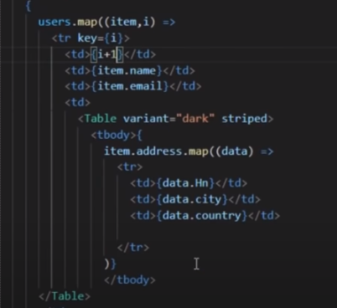

Re use of function inside the map :



App.js

import "./App.css";

import Col from './Col'

*function* App(){

*let* User=[

    {name:"Ajaj Alam" , id:"2020UMT1399" , contact:111},

    {name:"Ajaj Alam" , id:"2020UMT1399" , contact:111},

    {name:"Ajaj Alam" , id:"2020UMT1399" , contact:111},

    {name:"Ajaj Alam" , id:"2020UMT1399" , contact:111}

];

  return(

    <div className="App">

      {User.map((*items*)*=>*<*Col* data={*items*}></*Col*>

    )}

    </div>

  )

}

export default App;

Col.js

*function* Col(*props*){

  return(

    <div>

      <span>{*props*.data.name} , {*props*.data.id}</span>

    </div>

  );

}

export default Col;

interview question : If I have to want to use a function on the inside the external component , whether I have to define the function inside the external function or I have to define it in App.js ?

Ans : we can define a function in both . but defining a function inside external component is not a good practice because if we call it into the App.js . the more we call the same times the function will going to call that will increase the memory load . so we can define the function in App.js and pass the function as props.

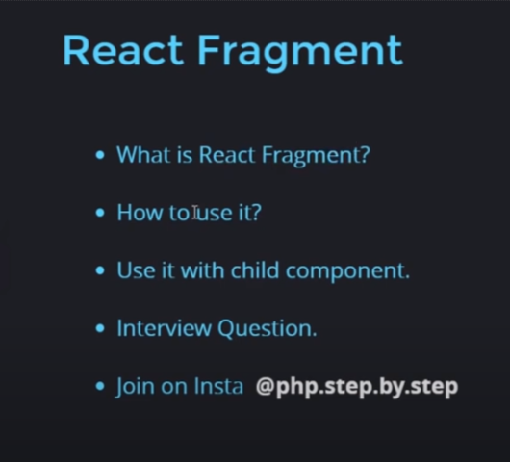

1.What is React Fragment ?

It is a pattern to handle multiple component or element.

Ex : in jss if we have to write to more than one child component the for that we have to use a div. but if we donot want div to appear in console for that we can we fragment .

2.How to use :

We have two fragment :

1. Import React ,{fragment} form ‘react’;
2. import React from 'react';
3. *function* Col(*props*){
4. return(
5. <*React.Fragment*>
6. <span>{*props*.data.name} , {*props*.data.id}</span>
7. <span>{*props*.data.name} , {*props*.data.id}</span>
8. </*React.Fragment*>
9. );
10. }
11. export default Col;

2. we can use : <> content </> this

Note : infrgment we can only take key as input .

🡺 Lifting state Up:



1.sending data from parent to child :

Sending data through <user data={} /> to user function

2.sending data from the child to parent :

Sending data from user function to -> App.js function or to <user />

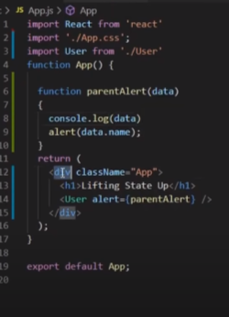 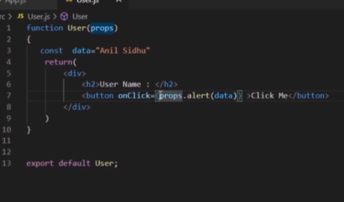

PURE COMPONENT :



1.what is pure component?

Pure component stop the re rendering of the same component again and again when state or prpos do not updated .

Note : Pure Component is only used for class component .

2.how to use purecomponent ?

It is only used for class component :

class class_name extends React.pureComponent{

}

3.pure component with the state?

import "./App.css";

import React from 'react';

import {Button} from 'react-bootstrap';

*class* App extends React.PureComponent{

*constructor*(){

    super();

    this.state={

      count:1

    }

  }

  render(){

    console.log("render is calling!");

    return(

      <div className="App">

        <h1>current count : {this.state.count}</h1>

        <*Button* className="bg-sucess" onClick={()*=>*{

          this.setState({count:1})

        }}>Click me</*Button*>

      </div>

    )

  }

}

export default App;

4.Pure Component with the porpos ?

App.js

import "./App.css";

import React from 'react';

import {Button} from 'react-bootstrap';

import Col from './Col'

*class* App extends React.PureComponent{

*constructor*(){

    super();

    this.state={

      data:"Ajaj"

    }

  }

  render(){

    console.log("render is calling!");

    return(

      <div className="App">

        <*Col* data={this.state.data}/>

        <*Button* className="bg-sucess" onClick={()*=>*{

          this.setState({data:"Anupam"})

        }}>Click me</*Button*>

      </div>

    )

  }

}

export default App;

Col.js

import React from 'react';

*function* Col(*props*){

  return(

    <div>

      <h1>User name :{*props*.data}</h1>

    </div>

  );

}

export default Col;

🡺 Use memo : is a hooks used for fuctional component .



**1.Why we use useMemo Hook?**

**Ans : it works just like purecomponent .**

import "./App.css";

import React from 'react';

import {Button} from 'react-bootstrap';

// import Col from './Col'

*function* App(){

*const* [count,setcount]=React.useState(1);

*const* [item,setitem]=React.useState(10);

*const* multicountmemo=React.useMemo(*function* multicount(){

    console.log("multi count");

    return count*5;

  },[count])

  return(

    <div className="App">

      <h1>count:{count}</h1>

      <h1>item:{item}</h1>

      <h3>{multicountmemo}</h3>

      <*Button* className="bg-danger mr-3 text-sucess" onClick={()*=>*{

        setcount(count+1);

      }}>Click 1</*Button*>

      <*Button* onClick={()*=>*{

        setitem(item*10);

      }}>Click 2</*Button*>

    </div>

  )

}

export default App;

**Q. can we use use effect instead of use memo ?**

**Ans : no , we can not use useeffect instead of usememo because useeffect donot return any thing .**

**Ref :**

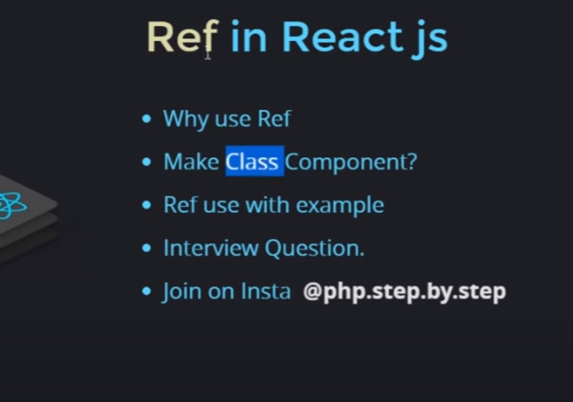

**Note :We can directly use ref in function component .**

**1.why ref ?**

**Through ref we can manipulate the dom . it is like a addEventListiner in js.**

import "./App.css";

import React from 'react';

import {Button} from 'react-bootstrap';

// import Col from './Col'

*class* App extends React.PureComponent{

*constructor*(){

    super();

    this.inputref=React.createRef();

  }

  render(){

    return(

      <div className="App">

        <input type="text" ref={this.inputref}/>

        <*Button* onClick={()*=>*{

          this.inputref.current.style.backgroundColor="green";

          console.log(this.inputref.current.value)

        }}>Click Me</*Button*>

      </div>

    )

  }

}

export default App;

**🡺 useref :**

**This is used to manipulate dom of function component.**

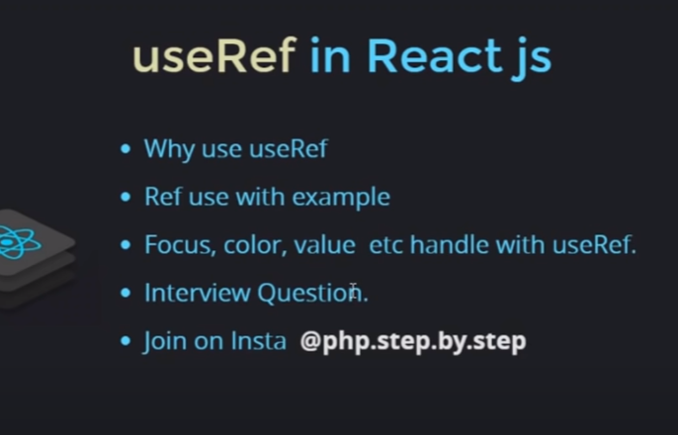

import "./App.css";

import React from 'react';

import {Button} from 'react-bootstrap';

// import Col from './Col'

*function* App(){

*const* inputref=React.useRef(null);

  return(

    <div className="App">

      <h1>use Ref</h1>

      <input type="text" ref={inputref}/>

      <*Button* className="bg-danger" onClick={()*=>*{

        inputref.current.style.border='2px red solid';

        inputref.current.value="Ajaj";

        inputref.current.focus();

      }}>Click me</*Button*>

    </div>

  )

}

export default App;

**Forward ref :**

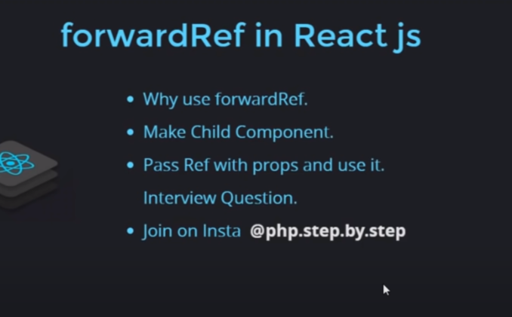

**It is advance version of ref . in ref we perform any dom manipulation by clicking on button int ref our both button and ref in same component . if our button and ref in different component then we will going to use forward ref.**

**App.js**

import "./App.css";

import React from "react";

import { Button } from "react-bootstrap";

import Col from './Col'

*function* App() {

*const* inputref = React.useRef(null);

  return (

    <div className="App">

      <h1>use of forwardref</h1>

      <*Col* ref={inputref}/>

      <*Button*

        className="bg-danger"

        onClick={() *=>* {

          inputref.current.style.border = "2px red solid";

          inputref.current.value = "Ajaj";

          inputref.current.focus();

        }}

      >

        Click me

      </*Button*>

    </div>

  );

}

export default App;

**Col.js**

import React from 'react';

*function* Col(*props*,*colref*){

  return(

    <div>

      <input type="text" ref={*colref*} />

    </div>

  );

}

export default React.forwardRef(Col);

note: we can use the forward ref in same way in class component ?

Controlled component :



1.What is controlled component?

Ans: if the input filed is controlled by state then those filed is control component.

Controlled input with value and defaultvalue

import "./App.css";

import React from "react";

// import { Button } from "react-bootstrap";

// import Col from './Col'

*function* App() {

*const* [val,setval]=React.useState("");

*const*[item,setitem]=React.useState("");

  return (

    <div className="App">

      <h1>Controlled Component</h1>

      <input type="text"  value={val} onChange={(*e*)*=>*{

        setval(*e*.target.value);

      }} /><br></br>

      <input type="text"  defaultValue="45455" onChange={(*e*)*=>*{

        setitem(*e*.target.value);

      }} />

    </div>

  );

}

export default App;

🡺 UNCONTROLLED COMPONENT :

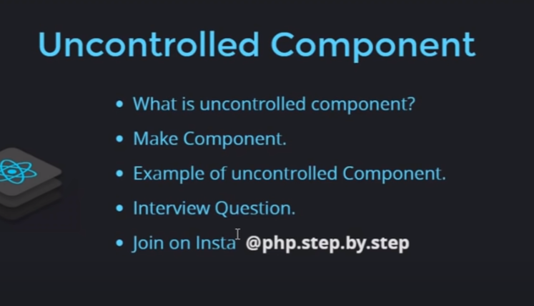

1.what is uncontrolled component?  
ans : the component which is controlled by ref or by java script are called as uncontrolled component.

High order component :

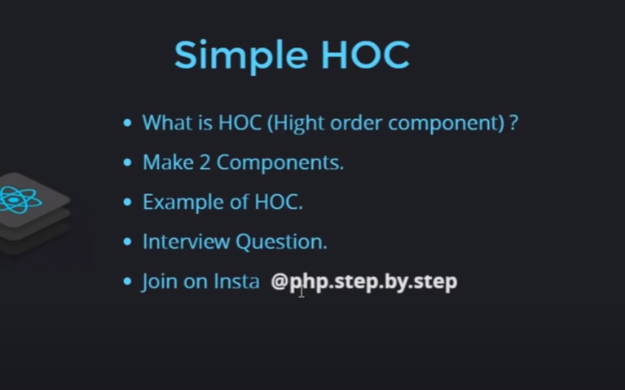

15.React router

1.To install run : npm i react-router-dom

2.import {BrowserRouter as Router} from ‘react-router-dom’

3.to create link: import {Link} from ‘react-router-dom’

import "./App.css";

import React from "react";

import { BrowserRouter as Router, Link, Route,Routes} from "react-router-dom";

export default *function* App() {

  return (

    <div className="App">

      <*Router*>

        <*Link* to="/Home">Home Page</*Link*><br></br>

        <*Link* to="/About">About Page</*Link*>

        <*Routes*>

          <*Route* path="/home" element={<*Home*/>}></*Route*>

          <*Route* path="/About" element={<*About*/>}></*Route*>

        </*Routes*>

      </*Router*>

    </div>

  );

}

*function* About() {

  return (

    <>

      <h1>This is about page</h1>

      <p>

        Lorem ipsum dolor, sit amet consectetur adipisicing elit. Nostrum, saepe

        corporis aperiam facere vel ea similique perspiciatis quia inventore

        voluptates ab aspernatur qui tempore accusamus ad numquam fugiat

        repellendus molestias.

      </p>

    </>

  );

}

*function* Home() {

  return (

    <div>

      <h1>This is Home page</h1>

      <p>

        Lorem ipsum dolor, sit amet consectetur adipisicing elit. Nostrum, saepe

        corporis aperiam facere vel ea similique perspiciatis quia inventore

        voluptates ab aspernatur qui tempore accusamus ad numquam fugiat

        repellendus molestias.

      </p>

    </div>

  );

}

Note : we we do not want to use Browser router the put browser Router in the index.js

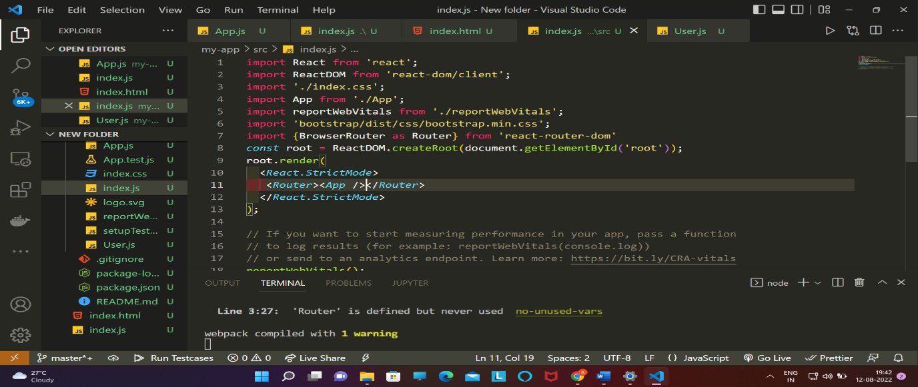

🡺To make 404 page : use * in path

  <*Route* path="*"  element={<h1>page not found</h1>}></*Route*>

Q.During creating link why we use Link why not anchor tag ?

Ans : this is because with the anchor tag it will going to refresh again and again but with the link it will going to open without refreshing the page .

16.Dynamic routing : we can do dynamic routing by importing : import {useparams} from ‘react-router-dom’;

*const* paarams=useParams();

*const* {id,name}=paarams;

APP.js

import "./App.css";

import { Link ,Routes ,Route} from "react-router-dom";

import User from './User'

export default *function* App() {

*let* Users = [

    { id: 1, name: "Ajaj Alam", contact: 111 },

    { id: 2, name: "Anupam", contact: 111 },

    { id: 3, name: "Aman ", contact: 111 },

    { id: 4, name: "Anurag", contact: 111 },

  ];

  return (

    <div className="App">

      {Users.map((*items*, *id*) *=>* (

        <ul key={*id* + 1}>

          <li>

            <*Link* to={`/user/${*items*.id}/${*items*.name}`}>{*items*.name}</*Link*>

          </li>

        </ul>

      ))}

      <*Routes*>

          <*Route* path="/user/:id/:name" element={<*User*/>}></*Route*>

      </*Routes*>

    </div>

  );

}

User.js

import React from "react";

import {useParams} from 'react-router-dom'

*function* User(){

*const* paarams=useParams();

*const* {id,name}=paarams;

    return(

        <div>

            <h1>User Component id :{id}</h1>

            <h1>User Component name :{name}</h1>

        </div>

    )

}

export default User;

17.Creating active link :

Note : while creating link with import: import {Navlink} form ‘react-router-dom’

We have by default class=”active” whenever the particular link is active so we can do styleing with the class=”active”

import './App.css';

import {NavLink,Routes,Route} from 'react-router-dom'

*function* App(){

  return(

    <div className="App">

     <ul style={{listStyle:"none"}}>

      <li><*NavLink* to='/'>Home</*NavLink*></li>

      <li><*NavLink* to='/about'>About</*NavLink*></li>

      <li><*NavLink* to='servics'>Services</*NavLink*></li>

     </ul>

     <*Routes*>

      <*Route* path='/' element={<*Home*/>}></*Route*>

      <*Route* path='/about' element={<*About*/>}></*Route*>

      <*Route* path='/Servics' element={<*Services*/>}></*Route*>

     </*Routes*>

    </div>

  )

}

*function* Home(){

  return(

    <h1>Welcome to home section</h1>

  )

}

*function* About(){

  return(

    <h1>Welcome to About section</h1>

  )

}

*function* Services(){

  return(

    <h1>Welcome to Services section</h1>

  )

}

export default App;

method 2.

By giving inline style :

style={({*isActive*})*=>*{return{ color:*isActive*?'black':'green'}}}

18.useSearchParam

It is use to get the value we passed with the middleware

Eg : /user?age=23

import './App.css';

import {NavLink,useSearchParams} from 'react-router-dom'

*function* App(){

*let* [searchParam,setSearchParam]=useSearchParams();

  console.log(searchParam.get('age'));

  return(

    <div className="App">

     <ul style={{listStyle:"none"}}>

      <li><*NavLink*  to='/'>Home</*NavLink*></li>

     </ul>

    </div>

  )

}

export default App;

ii)setting the value of paramas :

import './App.css';

import {NavLink,useSearchParams} from 'react-router-dom'

*function* App(){

*let* [searchParam,setSearchParam]=useSearchParams();

*let* age=searchParam.get('age');

  return(

    <div className="App">

     <ul style={{listStyle:"none"}}>

      <li><*NavLink*  to='/'>Home</*NavLink*></li>

     </ul>

     <button  onClick={()*=>*{

      setSearchParam({age:40});

     }}>setSearchParam</button>

    </div>

  )

}

export default App;

1. useNavigate state of ‘react-router-dom’ :

note : it is used to nagivate to a link a particular link on click of button .

import './App.css';

import {useNavigate,Route,Routes} from 'react-router-dom'

import User from './User';

*function* App(){

*let* navigate=useNavigate();

  return(

    <div className="App">

      <button onClick={()*=>*{

        navigate('./User');

      }}>Go To About Page</button>

  <*Routes*>

    <*Route* path='/User' element={<*User*/>}></*Route*>

  </*Routes*>

    </div>

  )

}

export default App;

20.Nested routing:



We can do nested routing by importing : import {oulet} from ‘react-router-dom’

App.js

import './App.css';

import {Route,Routes} from 'react-router-dom'

import User from './User';

import Company from './Company';

*function* App(){

  return(

    <div className="App">

      <*Routes*>

    <*Route* path='/User/' element={<*User*/>}>

      <*Route* path='company' element={<*Company*/>}></*Route*>

    </*Route*>

  </*Routes*>

    </div>

  )

}

export default App;

User.js

import React from "react";

import {Outlet,Link} from 'react-router-dom'

*function* User(){

    return(

        <>

        <h1>Hello Your At the users Page</h1>

        <*Link* to="company">Company</*Link*>

        <*Outlet*/>

        </>

    )

}

export default User;

1. uselocation hooks of : ‘react-router-dom’

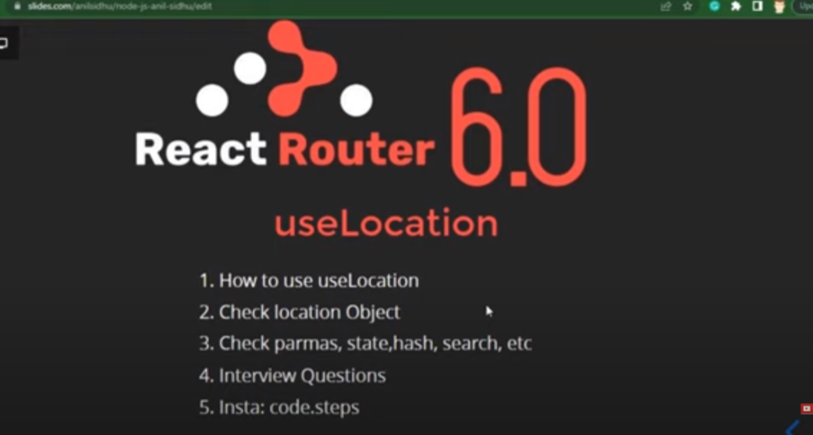

Q.what is the use of uselocation ?

Ans : whenever we are moving from one route to another route then with the help of uselocation we can get the information of :

i)pathname

ii)hash means “#some_info”

iii)key note : each route has its unique key

iv)search eg : ?age=18

v)most important we can send the information as well

1.To define useLocation :

Import {useLocation} from ‘react-router-dom’

Step 2=> let location=uselocation()

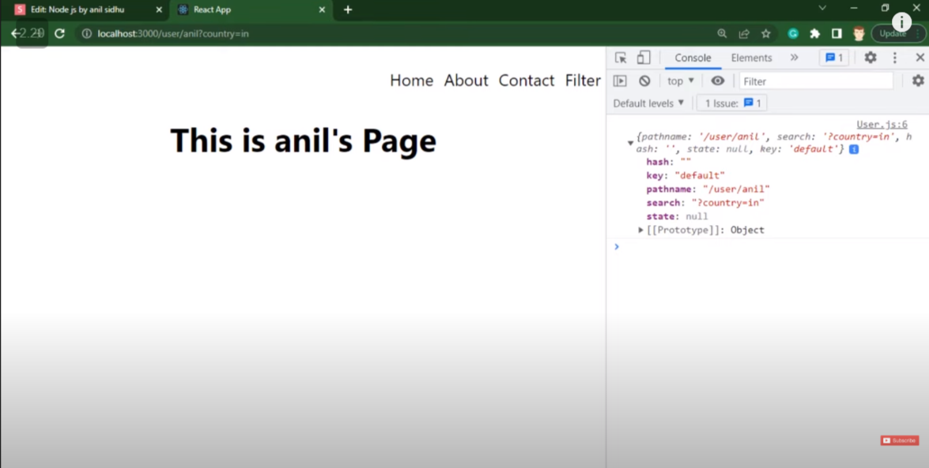

🡺Passing state and getting state in link by using use location

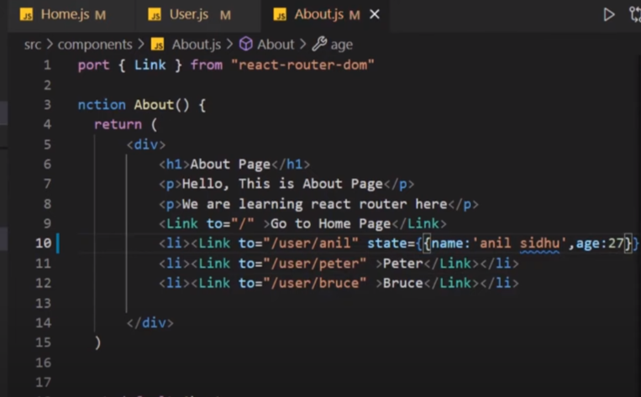

9.Protected route :

Through this we can make a procted route

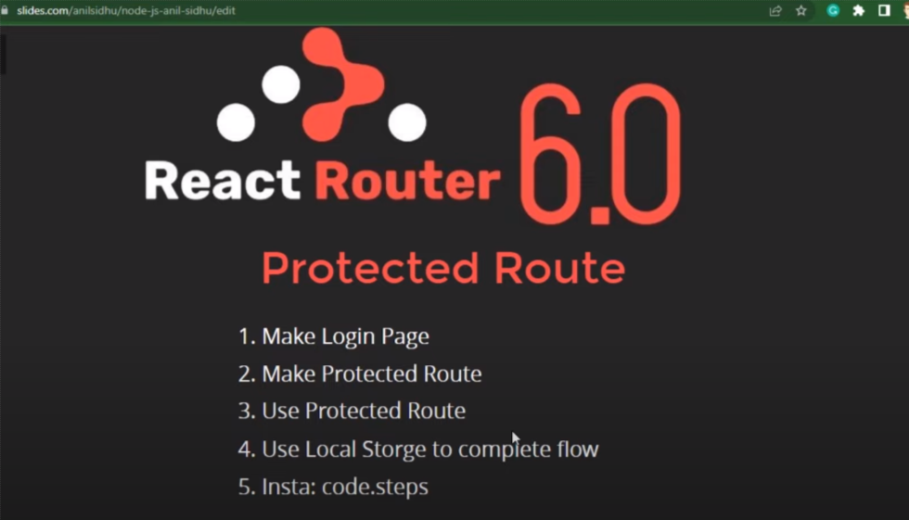

By using : localstorage.getItem() and localstorage.setitem() ;

🡺interviw question

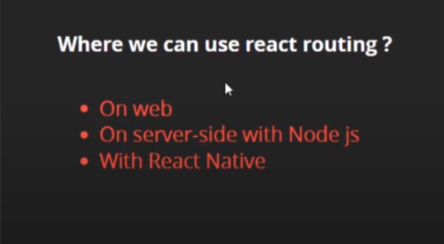





12.CRUD Operation with the Api

A)get method :

Here we are going to use state starting with the empty to inilised the data that have been fetched.

13.Geting previous state in functional component ?

i)

by using callback function inside the setstate and returning the updated value .

import "./App.css";

import {useState } from "react";

*function* App() {

*const* [data, setdata] = useState(1);

*function* dataincrease(){

*let* rand=Math.floor(Math.random()*10);

    setdata((*e*)*=>*{

      console.log(*e*);

      return rand;

    })

  }

  return (

    <>

    <div className="App">

      <h1>{data}</h1>

      <button onClick={dataincrease}>updata Data</button>

    </div>

    </>

  );

}

export default App;

ii) Set count with the loop

import "./App.css";

import {useState } from "react";

*function* App() {

*const* [data, setdata] = useState(1);

*function* dataincrease(){

    for(*let* i=1;i<=5;i++){

      setdata(data+1);

    }

  }

  return (

    <>

    <div className="App">

      <h1>{data}</h1>

      <button onClick={dataincrease}>updata Data</button>

    </div>

    </>

  );

}

export default App;

🡺To solve the above problem

import "./App.css";

import {useState } from "react";

*function* App() {

*const* [data, setdata] = useState(1);

*function* dataincrease(){

    for(*let* i=1;i<=5;i++){

      setdata((*e*)*=>*{

        return *e*+1;

      });

    }

  }

  return (

    <>

    <div className="App">

      <h1>{data}</h1>

      <button onClick={dataincrease}>updata Data</button>

    </div>

    </>

  );

}

export default App;

14. Getting previous value of the props using useref hook :

App.js

import "./App.css";

import { useState } from "react";

import User from "./User";

*function* App() {

*const* [data, setdata] = useState(1);

*function* dataincrease() {

*let* rand = Math.floor(Math.random() * 10);

    setdata(rand);

  }

  return (

    <>

      <div className="App">

        <*User* sendData={data}/>

        <button onClick={dataincrease}>updata Data</button>

      </div>

    </>

  );

}

export default App;

User.js

import {useEffect, useRef} from 'react'

export default *function* User(*props*){

*let* inputref=useRef();

  useEffect(()*=>*{

    inputref.current=*props*.sendData;

  })

*let* previous=inputref.current;

  return(

    <>

    <h1>previous:{previous}</h1>

    <h1>send data :{*props*.sendData}</h1>

    </>

  )

}